1. Found nothing suspicious in network_security_config.xml.

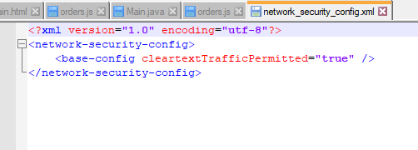

1. The only way to register is through binding your Arknights google account with Twitter, Facebook or YoStar accounts.  
   But for recovering account there is only 1 way – through support:

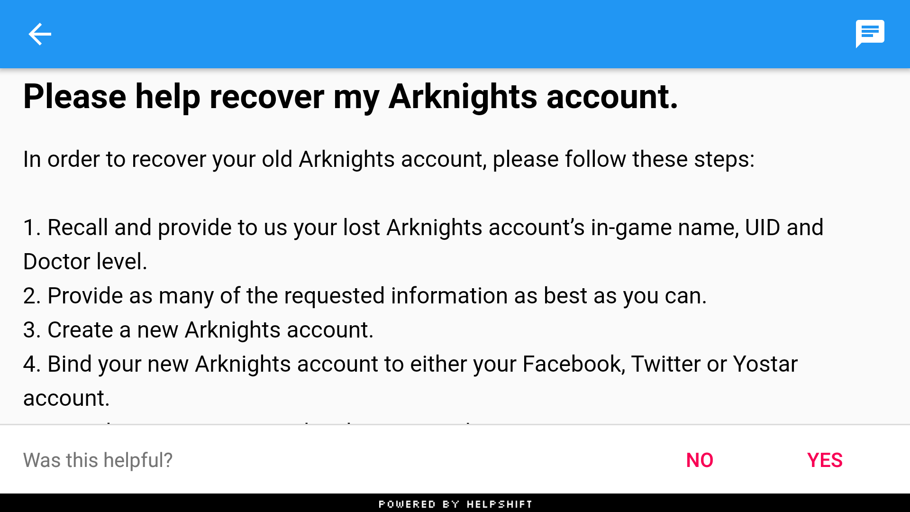

1. Here is what I found on ProviderInstaller:

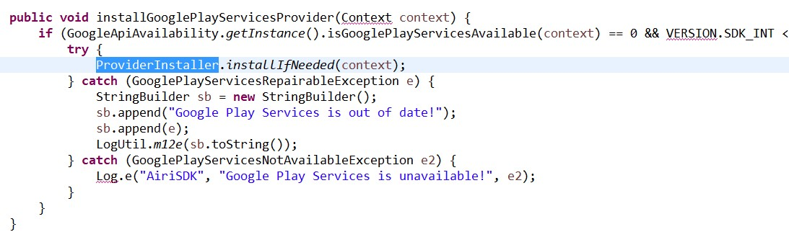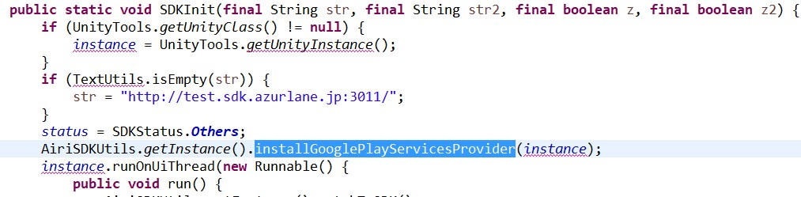

So basically ProviderInstaller is called almost instantly after starting the app. But exceptions are not handled correctly, they are just logged and nothing happens after. So this can be a vulnerability.